***TASK 1:***

#include<iostream>

using namespace std;

class adjacency_Matrix

{

public:

int** row_array;

int row;

int col;

adjacency_Matrix(int Size);

adjacency_Matrix(int row_size, int col_size);

void inserting_Edge(int num1, int num2);

void display_Matrix();

};

adjacency_Matrix::adjacency_Matrix(int Size)

{

row = Size;

col = Size;

row_array = new int* [row];

for (int i = 0; i < row; i++)

{

row_array[i] = new int[col];

}

for (int i = 0; i < row; i++)

{

for (int j = 0; j < col; j++)

{

row_array[i][j] = 0;

}

}

}

adjacency_Matrix::adjacency_Matrix(int row_size, int col_size)

{

row = row_size;

col = col_size;

row_array = new int* [row];

for (int i = 0; i < row; i++)

{

row_array[i] = new int[col];

}

for (int i = 0; i < row; i++)

{

for (int j = 0; j < col; j++)

{

row_array[i][j] = 0;

}

}

}

void adjacency_Matrix::inserting_Edge(int num1, int num2)

{

if (num1 > row || num2 > col || num1 < 0 || num2 < 0)

{

cout << "Invalid Entry" << endl;

}

else

{

row_array[num1][num2] = 1;

row_array[num2][num1] = 1;

}

}

void adjacency_Matrix::display_Matrix()

{

for (int i = 0; i < row; i++)

{

for (int j = 0; j < col; j++)

{

cout << row_array[i][j] << " ";

}

cout << endl;

}

}

int main()

{

int num1;

int num2;

int rows;

int cols;

cout << "Enter number of rows::";

cin >> rows;

cout << "Enter number of coloumns::";

cin >> cols;

adjacency_Matrix Obj(rows, cols);

for (int i = 0; i < cols; i++)

{

cout << "Enter Edges::";

cin >> num1 >> num2;

Obj.inserting_Edge(num1 - 1, num2 - 1);

}

cout << endl;

cout << "Adjacency Matrix::" << endl;

Obj.display_Matrix();

system("pause");

return 0;

}

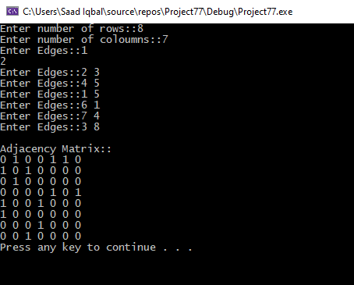

***TASK 2:***

#include<iostream>

using namespace std;

class adjacency_Matrix

{

public:

int** row_array;

int row;

int col;

adjacency_Matrix(int Size);

adjacency_Matrix(int row_size, int col_size);

void inserting_Edge(int num1, int num2);

void display_Matrix();

void edge_count(int num1,int num2);

};

adjacency_Matrix::adjacency_Matrix(int Size)

{

row = Size;

col = Size;

row_array = new int* [row];

for (int i = 0; i < row; i++)

{

row_array[i] = new int[col];

}

for (int i = 0; i < row; i++)

{

for (int j = 0; j < col; j++)

{

row_array[i][j] = 0;

}

}

}

adjacency_Matrix::adjacency_Matrix(int row_size, int col_size)

{

row = row_size;

col = col_size;

row_array = new int* [row];

for (int i = 0; i < row; i++)

{

row_array[i] = new int[col];

}

for (int i = 0; i < row; i++)

{

for (int j = 0; j < col; j++)

{

row_array[i][j] = 0;

}

}

}

void adjacency_Matrix::inserting_Edge(int num1, int num2)

{

if (num1 > row || num2 > col || num1 < 0 || num2 < 0)

{

cout << "Invalid Entry" << endl;

}

else

{

row_array[num1][num2] = 1;

row_array[num2][num1] = 1;

}

}

void adjacency_Matrix::edge_count(int num1,int num2)

{

}

void adjacency_Matrix::display_Matrix()

{

for (int i = 0; i < row; i++)

{

for (int j = 0; j < col; j++)

{

cout << row_array[i][j] << " ";

}

cout << endl;

}

}

int main()

{

int num1;

int num2;

int rows;

int cols;

int count=0;

cout << "Enter number of rows::";

cin >> rows;

cout << "Enter number of coloumns::";

cin >> cols;

adjacency_Matrix Obj(rows, cols);

for (int i = 0; i < cols; i++)

{

cout << "Enter Edges::";

cin >> num1 >> num2;

Obj.inserting_Edge(num1 - 1, num2 - 1);

count++;

}

cout << endl;

cout << "Adjacency Matrix::" << endl;

Obj.display_Matrix();

cout << "Total number of edges are :" << count<<endl;

system("pause");

return 0;

}

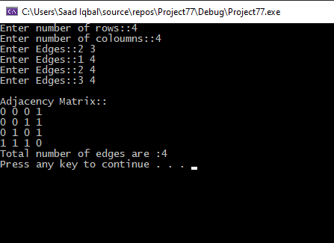

**TASK 3:**

#include<iostream>

using namespace std;

class adjacency_Matrix

{

public:

int** row_array;

int row;

int col;

int **arr;

int result[5][5] = {0};

adjacency_Matrix(int Size);

adjacency_Matrix(int row_size, int col_size);

void inserting_Edge(int num1, int num2);

void display_Matrix();

void input(int row,int col);

void transpose_mul();

};

adjacency_Matrix::adjacency_Matrix(int Size)

{

row = Size;

col = Size;

row_array = new int* [row];

for (int i = 0; i < row; i++)

{

row_array[i] = new int[col];

}

for (int i = 0; i < row; i++)

{

for (int j = 0; j < col; j++)

{

row_array[i][j] = 0;

}

}

}

adjacency_Matrix::adjacency_Matrix(int row_size, int col_size)

{

row = row_size;

col = col_size;

row_array = new int* [row];

for (int i = 0; i < row; i++)

{

row_array[i] = new int[col];

}

for (int i = 0; i < row; i++)

{

for (int j = 0; j < col; j++)

{

row_array[i][j] = 0;

}

}

arr = new int* [row];

for (int i = 0; i < row; i++)

{

arr[i] = new int[col];

}

for (int i = 0; i < row; i++)

{

for (int j = 0; j < col; j++)

{

arr[i][j] = 0;

}

}

}

void adjacency_Matrix::inserting_Edge(int num1, int num2)

{

if (num1 > row || num2 > col || num1 < 0 || num2 < 0)

{

cout << "Invalid Entry" << endl;

}

else

{

row_array[num1][num2] = 1;

row_array[num2][num1] = 1;

}

}

void adjacency_Matrix::input(int row, int col)

{

cout << "Enter the values of adjacency matrix " << endl;

for (int j = 0; j < row; j++)

{

for (int i = 0; i < col; i++)

{

cout << "Enter the element [" << j << "][ " << i<<"] :";

cin >> row_array[j][i];

}

}

}

void adjacency_Matrix::transpose_mul()

{

for (int j = 0; j < row; j++)

{

for (int i = 0; i < col; i++)

{

arr[i][j]= row_array[j][i];

}

}

cout << "Transpose of a matrix" << endl;

for (int i = 0; i < row; i++)

{

for (int j = 0; j < col; j++)

{

cout<<arr[i][j]<<" ";

}

cout << endl;

}

for (int i = 0; i < row; i++)

{

cout << i + 1 << " -----> ";

for (int j = 0; j < col; j++)

{

if (row_array[i][j] == 1)

{

cout << j + 1 << " -----> ";

}

}

cout << endl;

}

for (int i = 0; i < row; i++)

{

for (int j = 0; j < col; j++)

{

result[i][j] = 0;

for (int k = 0; k < col; k++)

{

result[i][j] += arr[k][i] * row_array[j][k];

}

}

}

cout << endl;

cout << "Result after multiplication :"<<endl;

for (int i = 0; i < row; i++)

{

for (int j = 0; j < col; j++)

{

cout << result[i][j]<<" ";

}

cout << endl;

}

}

void adjacency_Matrix::display_Matrix()

{

for (int i = 0; i < row; i++)

{

for (int j = 0; j < col; j++)

{

cout << row_array[i][j] << " ";

}

cout << endl;

}

}

int main()

{

int num1;

int num2;

int rows;

int cols;

int count=0;

cout << "Enter number of rows::";

cin >> rows;

cout << "Enter number of coloumns::";

cin >> cols;

adjacency_Matrix Obj(rows, cols);

Obj.input(rows, cols);

Obj.display_Matrix();

cout << endl;

Obj.transpose_mul();

}

**As after multiplication adjacency list of matrix cannot be found. So I’ve perform adjacency operation on the original matrix**

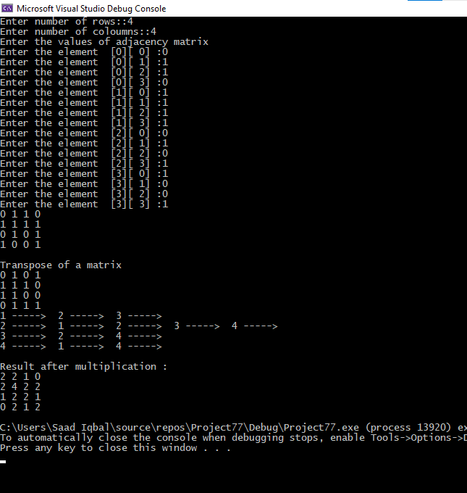

***TASK 4:***

#include<iostream>

using namespace std;

struct Node

{

int data;

Node* next;

};

class Adjacency_List

{

public:

Node* head;

};

class Adjacency_Matrix

{

public:

int** row_array;

int data;

Adjacency_List* obj_array;

Adjacency_Matrix(int data);

void print_adj_List(int);

void print_Matrix(int);

void print_List(int);

void data_Setting(int num1, int num2, int wieght);

};

Adjacency_Matrix::Adjacency_Matrix(int data)

{

data = data;

obj_array = new Adjacency_List[data];

for (int i = 0; i < data; ++i)

{

obj_array[i].head = NULL;

}

row_array = new int* [data];

for (int i = 0; i < data; i++)

{

row_array[i] = new int[data - 1];

for (int j = 0; j < data; j++)

{

row_array[i][j] = 0;

}

}

}

void Adjacency_Matrix::print_List(int a)

{

for (int i = 0; i < a; i++)

{

cout << i + 1;

for (int j = 0; j < a; j++)

{

if (row_array[i][j] != 0)

{

cout << " (" << row_array[i][j] << ") --> " << j + 1;

}

}

cout << endl;

}

}

void Adjacency_Matrix::print_Matrix(int a)

{

for (int i = 0; i < a; i++)

{

for (int j = 0; j < a; j++)

{

cout << row_array[i][j] << " ";

}

cout << endl;

}

}

void Adjacency_Matrix::data_Setting(int num1, int num2, int weight)

{

row_array[num1][num2] = weight;

row_array[num2][num1] = weight;

}

int main()

{

int n = 0, m = 0, a = 0, b = 0;

int option = 0;

int count = 0;

cout << "Enter number of vertices::";

cin >> n;

if (option != 5)

{

cout << "Enter the number of egdes:";

cin >> m;

Adjacency_Matrix obj(n);

for (int i = 0; i < m; i++)

{

cout << "Enter the 1st coordinates of " << i + 1 << " egde:";

cin >> a;

while (a > n)

{

cout << "\n\t\tWrong vertice \nEnter again :: ";

cin >> a;

}

cout << "Enter the 2nd coordinates of " << i + 1 << " egde:";

cin >> b;

while (b > n)

{

cout << "\n\t\tWrong vertice \nEnter again :: ";

cin >> b;

}

a -= 1; b -= 1;

cout << "Enter Weight:";

int wei[5];

cin >> wei[i];

obj.data_Setting(a, b, wei[i]);

for (int j = 0; j < m; j++)

{

if (wei[i] == wei[j+1])

{

count++;

}

}

}

cout << "\t\tAdjacency Matrix:" << endl;

obj.print_Matrix(n);

cout << "Common edges are :" << count<<endl;

}

}

